Exp 6: Automating Business Processes using Deluge Scripting and Workflows, with Application Testing and Debugging

- Aim
To design and configure an automated business process workflow within the Zoho Creator application using form-level workflow automation and declarative notification actions, and to successfully conduct application testing and live debugging to verify real-time email notification execution upon record submission in the Service_Request_Form Report.
- Procedure
Step 1: Access Workflow Builder and Initialize Workflow Trigger
In the Zoho Creator Application Builder for Vehicle Services & Repair Request, navigated to the Workflow tab in the top navigation bar. Clicked New Workflow to launch the workflow trigger configuration palette ("Run workflow on any event in the form") and specified the following trigger parameters.
- Choose form: Service_Request_Form Report
- Run when a record is (Record Event): Created
- When to trigger workflow (Form Event): Successful form submission
- Name the workflow: Send registration email
Clicked the blue Create Workflow button to generate the workflow pipeline.
Step 2: Add New Action via Notification Panel
Inside the visual Workflow Builder canvas under the trigger block Report > Created > Successful form submission > Send registration email), clicked + Add New Action. From the available action categories (Notification, Data access, Integrations, and Deluge script), selected the Notification tab ("Notify through email, SMS. Redirect to URL"). Under the Select an action menu:
- Send email
- Send SMS
- Send notification
- Show success message
- Redirect to a URL
Selected Send email to open the email configuration drawer.
Step 3: Configure Email Notification Parameters and Message Template
Configured the email dispatch settings within the Send email action panel:
- From*: Configured as notifications@nithiyasree.me (with the platform deliverability notice: "To improve deliverability, emails will be sent through our domain if unauthenticated or public domain is used. Learn more").
- To*: Dynamically mapped to the customer email field tag $ {Email_Address} via the field picker so that each notification routes directly to the submitter.
- Bcc: Configured administrative delivery tracking by adding contact@nithiyas (with options to Add Cc, Add Reply-to, or Remove Bcc).
- Subject: Entered Record Added.
- Message: Formatted the message body using the rich-text editor (Font: Dej aVuSans, Size: 10) and embedded dynamic system parameters:
${zoho . loginuserid} has added a record in form Service_Request _ Form Report
- Advanced Options: Checked Include user submitted data and set appropriate Content type to format data payloads.
Clicked Save to persist the notification action.
Step 4: Inspect Visual Workflow Logic and Finalize
Reviewed the visual workflow diagram rendered on the canvas. The trigger block connects directly to the execution condition block marked Execute without condition containing the action tile Send mail to ${Email_Address}. Clicked Done in the top header to finalize and register the workflow.
Step 5: Verify Active Workflow Status in Application Management Dashboard
Navigated to the Zoho Creator application dashboard under the Workflow tab > Form workflows sub-tab. In the left navigation list under Forms with workflows, selected Service_Request_ Form Report and verified that the newly created workflow appears in the workflow directory with the following verified attributes:
- Workflow Name: Send registration email
- Event Group: Created > Successful form submission
- Details: 1 Action
- Status: Enabled (toggle switch active/green)
- Created On: 06 -Oct -2026
Step 6: Live Application Testing and End-to-End Verification
Accessed the published live user interface of the Vehicle Services & Repair Request application, navigated to the service request form, and submitted a test record with customer details and a valid email address. Monitored delivery logs and checked the recipient Gmail inbox to confirm end-to-end execution without delay.

3. Output
3.1 Workflow Trigger Configuration — Defining Form Event Properties
The initial workflow setup modal demonstrates the target form selection, record creation event trigger, and workflow naming.
Run workflow on any event in the form
Cmted Edited
When to trigge
Name 'he 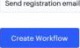
Figure 1: Zoho Creator Workflow Builder Configuring Trigger Event Properties for "Send registration email"
3.2 Action Category Palette — Selecting "Notification > Send email"
The action selection interface displays the four available action categories, highlighting the Notification suite and the Send email option.
o | 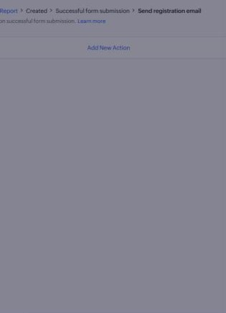 | 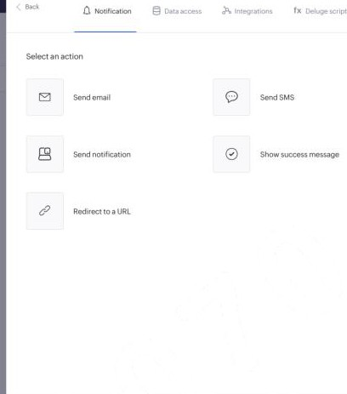
Figure 2: Action Selection Panel — Choosing "Notification > Send email" Action Type
3.3 Email Notification Editor — Configuring Delivery Headers & Template
The Send email drawer showing Sender (From), dynamic recipient (${Email_Address}), Bcc address, Subject line, and rich text body template with dynamic Zoho tags.
 | 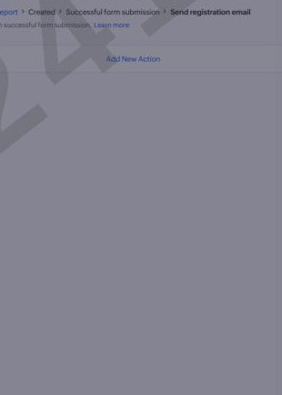 | 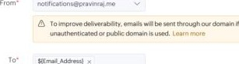  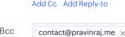  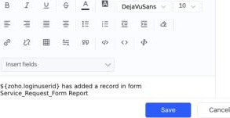  Send email  1  Subieet Added  Trial in
Figure 3: Notification Configuration Drawer Customizing "Send email" Parameters and Message Body
3.4 Visual Workflow Canvas — Finalized "Execute without condition " Block
The visual workflow pipeline canvas showing the active action card configured to dispatch mail to ${Email_Address} without preconditions.
email
o
Figure 4: Visual Workflow Canvas — Configured Action Block ("Execute without condition > Send mail to ${Email_Address}")
3.5 Application Workflow Directory — Active " Send registration email" Workflow
The Form workflows dashboard confirming that the "Send registration email" workflow is registered, configured with 1 Action, and set to Enabled status.
Vehicle Services Request
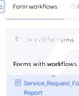 |  |  | 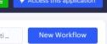  W.(rt.2026
Trial in _Oiiå@ié_
Figure 5: Zoho Creator Workflow Dashboard Active and Enabled "Send registration email" Workflow Entry
3.6 Target Email Inbox — Delivered Live Automated Confirmation Message
The Gmail inbox confirming real-time receipt of the automated confirmation email with Subject "Record Added" sent from notifications@trial.zohocreatormail.com.
M Gr-näl  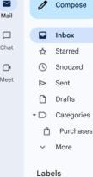 | 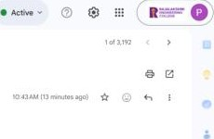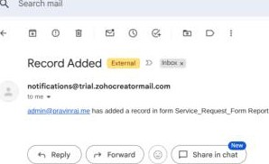
Figure 6: Live Customer Email Inbox (Gmail) Delivered Automated Notification Message ("Record Added")

4. Result / Observations
The automated business process workflow was successfully designed, configured, and tested in Zoho Creator:
- A form-level automated workflow trigger was established on the Report to listen for Created > Successful form submission events.
- A declarative Notification action (Send email) was configured with dynamic recipient binding (${EmaiI_Address}), audit routing via Bcc mic template variable resolution (${ zoho . loginuserid}).
- The workflow was verified as active and enabled within the Zoho Creator application workflow management console.
- Live application execution successfully triggered instant email routing and verified delivery to the target email inbox from notifications@trial . zohocreatormail . com with the subject "Record Added".

